CHAPTER-1

Network Topologies and Architectures

The key elements of a LAN are: Topology, Transmission medium, Wiring layout, and Medium access control. Together, these elements determine not only the cost and capacity of the LAN, but also the type of data that may be transmitted, the speed and efficiency of communications, and even the kinds of applications that can be supported.

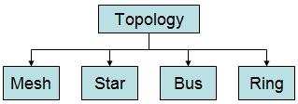
3.1 Physical Topology of Network
In the context of a communication network, the term topology refers to the way in which the end points, or stations, attached to the network are interconnected. The topology of a network is the geometric representation of the relationship of all the links and linking devices (usually called nodes) to one another. The common topologies for LANs are mesh, star, bus, and ring. The bus is a special case of the tree, with only one trunk and no branches.

3.1.1 Mesh Topology
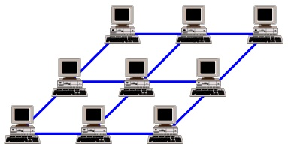
In a mesh topology, every device has a dedicated point-to-point link to every other device. In a fully connected mesh network with n nodes, there are total of {n (n-1)/2} links & each node is connected to (n-1) nodes, so every device on the network has (n-1) I/O port. One practical example of a mesh topology is the connection of telephone regional offices in which each regional office needs to be connected to every other regional office.
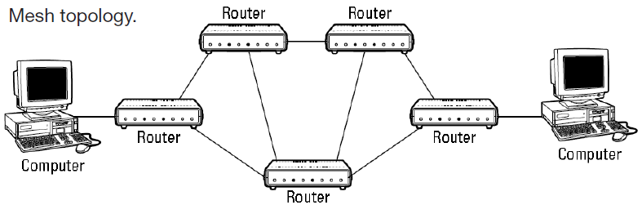

Advantages
A mesh offers several advantages over other network topologies, some are as follows:
- The use of dedicated links guarantees that each connection can carry its own data load, thus eliminating the traffic problems that can occur when links must be shared by multiple devices.
- A mesh topology is robust i.e. if one link becomes unusable, it does not incapacitate the entire system.
- There is the advantage of privacy or security. When every message travels along a dedicated line, only the intended recipient sees it. Physical boundaries prevent other users from gaining access to messages.
- Point-to-point links make fault identification and fault isolation easy.

Limitations
- Because every device must be connected to every other device, installation and reconnection are difficult.
- Require larger spaces for wiring & cabling.
- The hardware required to connect each link (I/O ports and cable) can be prohibitively expensive.

3.1.2 Star Topology
In a star topology, each device has a dedicated point-to-point link only to a central controller, usually called a hub. The devices are not directly linked to one another. Unlike a mesh topology, a star topology does not allow direct traffic between devices. The controller acts as an exchange: If one device wants to send data to another, it sends the data to the controller, which then relays the data to the other connected device. The star topology is used in local-area networks (LANs) as well as in high-speed LANs with a central hub.
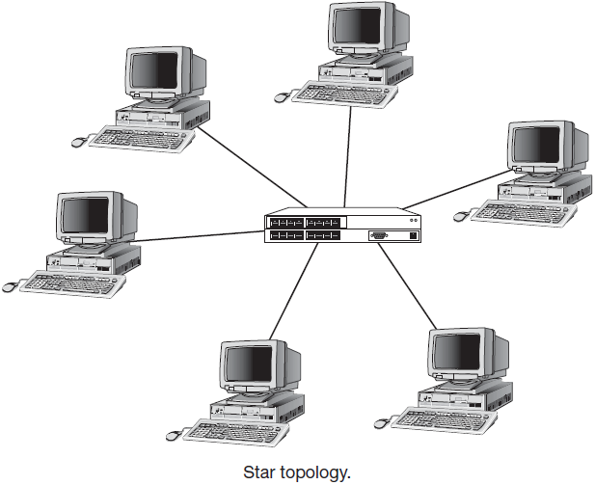
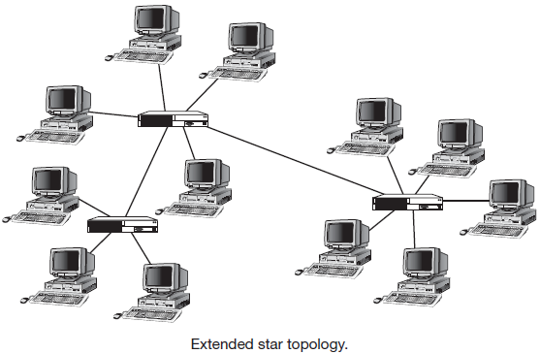

Advantages
- A star topology is less expensive than a mesh topology.
- In a star, each device needs only one link and one I/O port to connect it to any number of others. This factor also makes it easy to install and reconfigure.
- Far less cabling needs.
- Robust: Failure of one link doesn’t affect remaining network so, defecting link can be bypassed.

Limitations
- One big drawback of a star topology is the dependency of the whole topology on one single point, the hub. If the hub goes down, the whole system is dead.

3.1.3 Bus Topology
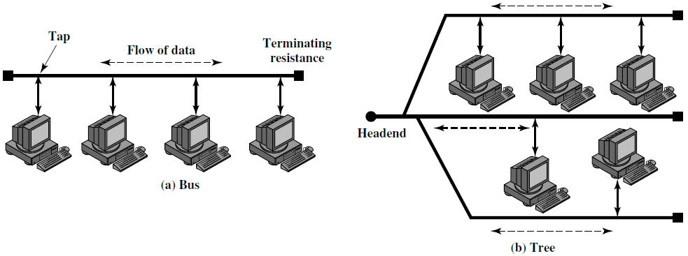
A bus topology is multipoint connection from a single data carrying cable. One long cable acts as a backbone to link all the devices in a network. Nodes are connected to the bus cable by drop lines and taps. A drop line is a connection running between the device and the main cable. A tap is a connector that either splices into the main cable or punctures the sheathing of a cable to create a contact with the metallic core. Bus topology was the one of the first topologies used in the design of early local area networks. Ethernet LANs can use a bus topology, but they are less popular now.

Advantages
- Easy to installation.
- Use less cabling than mesh & star topology.

Limitations
- Difficult in reconnection and fault isolation.
- A single fault or break in the bus cable stops all transmission.
- When two or more stations want to send data simultaneously through common bus, collision may occur.

3.1.4 Ring Topology
In a ring topology, each device has a dedicated point-to-point connection with only the two devices on either side of it. A signal is passed along the ring in one direction, from device to device, until it reaches its destination. Each device in the ring incorporates a repeater. When a device receives a signal intended for another device, its repeater regenerates the bits and passes them along (The terminators is not required to connect the two ends.).
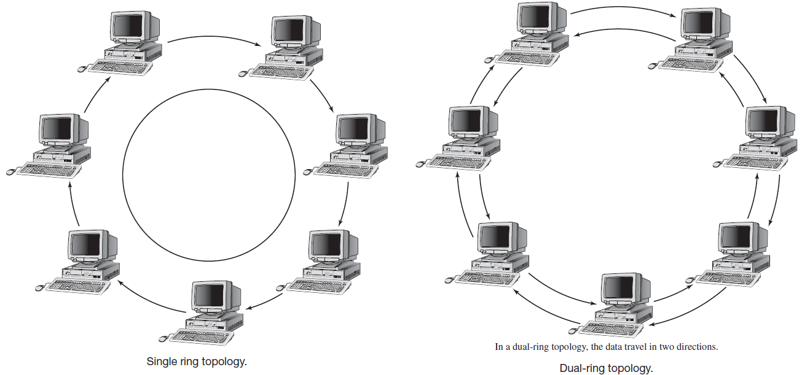

Advantages
- Relatively easy to install & reconfigure.
- Fault isolation is simplified.
- Each device is linked to only its immediate neighbors (either physically or logically). To add or delete a device requires changing only two connections.

Limitations
- In ring, a break in the ring can disable the entire network.
- Unidirectional traffic may create problem in data flow.

3.2 Network Architectures
The network’s architecture influences a network’s design, the computers included in the network, and how these computers interact with each other and with the user. If you know the architecture on which a network is based, you have a general idea of how resources are shared on the network and of network security structure.

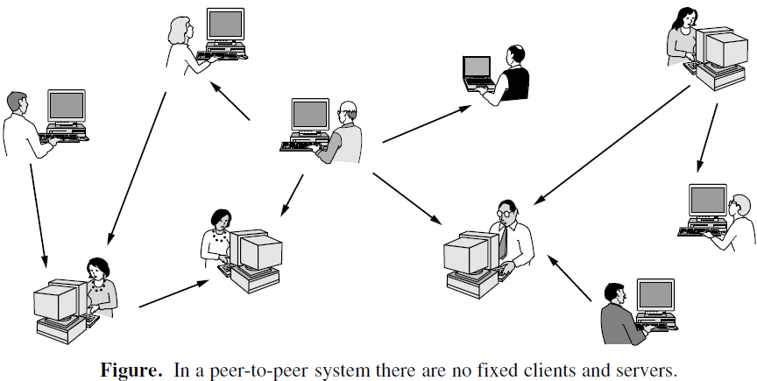
3.2.1 Peer-to-Peer Networks
Peer-to-peer network is a network architecture in which each computer can act as both a server and a client with no central security control. In peer-to-peer networks, users share their computers’ resources, making them available to other users. Peer-to-peer networks were available as early as 1984 by Apple Computer. Microsoft also introduced peer-to-peer networking capabilities in 1992.

The basic idea of a P2P (Peer-to-Peer) file-sharing network is that many computers come together and pool their resources to form a content distribution system. The computers are often simply home computers. They do not need to be machines in Internet data centers. The computers are called peers because each one can alternately act as a client to another peer, fetching its content, and as a server, providing content to other peers. What makes peer-to-peer systems interesting is that there is no dedicated infrastructure. Everyone participates in the task of distributing content, and there is often no central point of control.

Peer-to-peer networking lets one user access a file or printer connected and/or shared on another user’s computer across the network, thereby reducing costs associated with a centralized server or multiple printers. The most popular peer-to-peer networks have advanced to the point that peer-to-peer networks are accessible over the Internet for use in online gaming, virtual reality, and peer-to-peer file sharing applications.

Peer-to-peer networks are uniquely suited to situations with significant budgetary constraints preventing client-server or directory-based model. Peer-to-peer networking enables decentralized resource sharing. Specific characteristics include:
  - It allows users to share many resources from their computers, including files and printers.
  - It’s best suited to groups of 12 or fewer users, though some manufacturers suggest configurations with up to 20 users.
  - It’s decentralized so that user files are not stored in a central location.
  - It allows computers (and users) to communicate easily.

Peer-to-peer networking is built into the operating system software on your computer. After the software is configured on each workstation, users are responsible for making their specific information available to others (sharing it) and managing the access to that information. To secure the peer-to-peer networks, sometimes we use share-level security, which gives the users the authority to assign passwords to the local resources on their computers.

3.2.2 Client-Server Networks
Communication on the Internet is not defined as the exchange of data between two nodes or between two hosts. Real communication takes place between two processes (application programs). The transport layer is responsible for process-to-process delivery-the delivery of a packet, part of a message, from one process to another. Two processes communicate in a client/server relationship. A process on the local host, called a client, needs services from a process usually on the remote host, called a server.
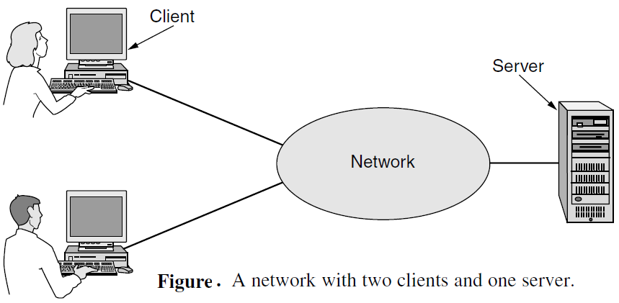
Client/server network is a network model that closely matches the mainframe network model, with servers providing resources to the network and clients consuming resources. A defining feature of this type of network is centralized security control and also known as a server-based network.

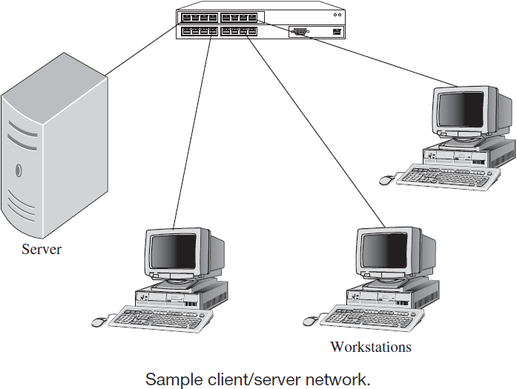
The client/server network architecture is a centralized model for data storage, security, network applications, and network administration. The client/server architectural model, along with its more recent variations, is the most common networking architectures in use today. Many companies that started with peer-to-peer networking quickly outgrew that model and had to find better networking solutions.

Characteristics of client/server networks include:
- They’re based on a scalable model that can support small networks of a few (less than ten) users up to large networks with thousands of users.
- They employ specialized servers that provide services to the client workstations.
- They provide shared services such as print and fi le services.
- They allow a high level of security based on access permissions.
- They can be centrally managed by a network administrator or a team of network administrators.

The basic criteria for selecting a client/server network are:
  - Files need to be stored centrally.
  - Security is important to protect sensitive and valuable data.
  - Users will need access to the server applications, shared data, and other resources.
  - One or more network administrators will be managing the server(s).
  - It has too many users for a peer-to-peer network.

This client-server interaction is also known as request-reply behavior. Communication between a client and a server can be implemented by means of a simple connectionless protocol when the underlying network is fairly reliable as in many local-area networks. In these cases, when a client requests a service, it simply packages a message for the server, identifying the service it wants, along with the necessary input data. The message is then sent to the server. The latter, in turn, will always wait for an incoming request, subsequently process it, and package the results in a reply message that is then sent to the client. Under most conditions, one server can handle a large number (hundreds or thousands) of clients simultaneously. Using a connectionless protocol, the message will be lost and hence the request-replay mechanism will be affected. As an alternative, many client-server systems use a reliable connection oriented protocol.

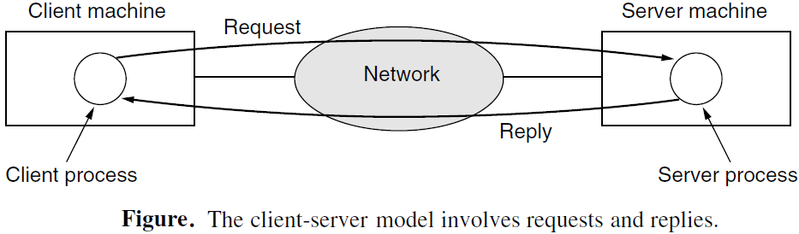
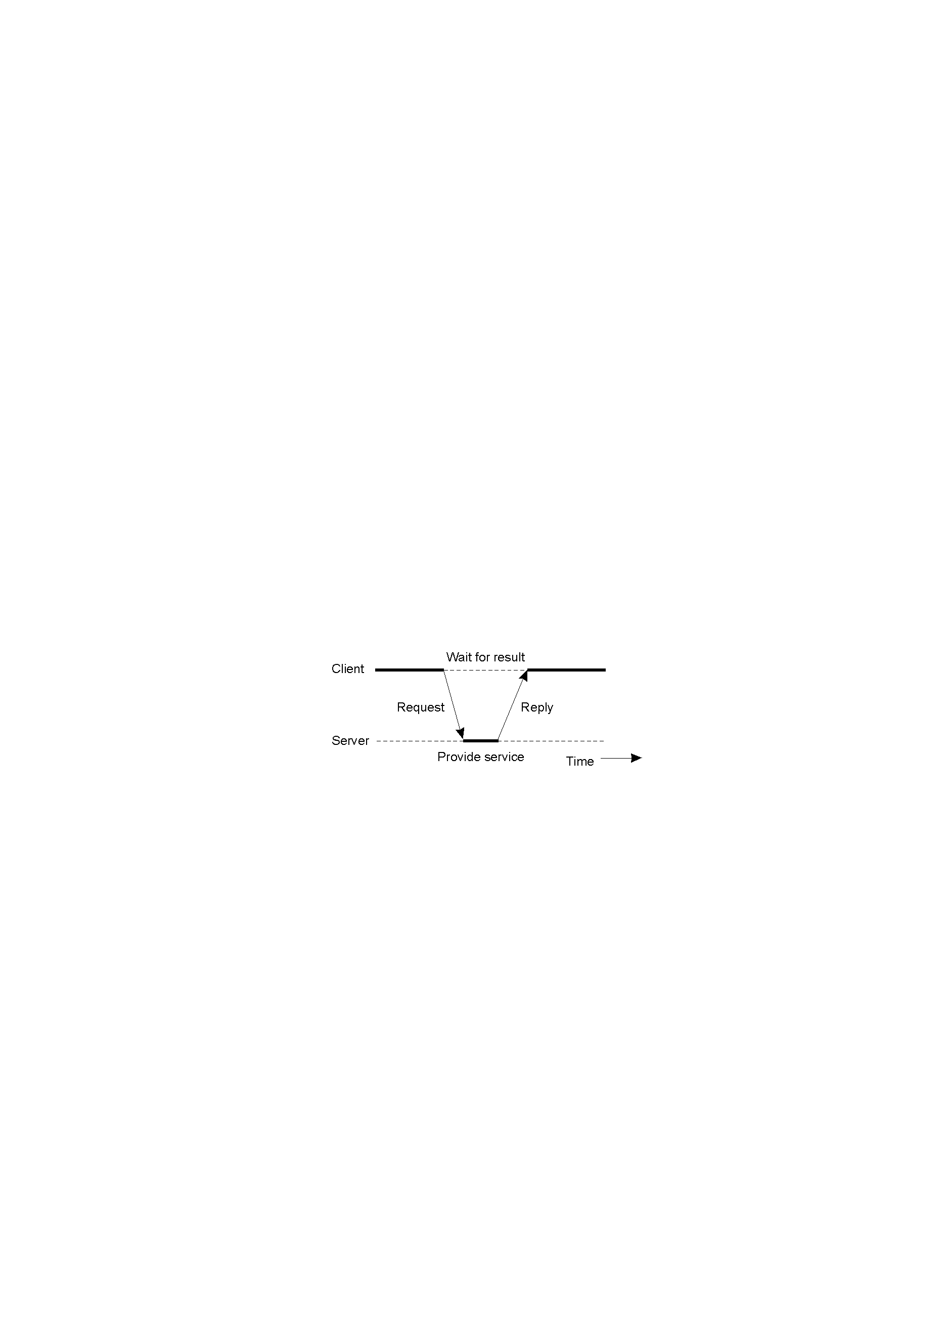

The client-server model is also implemented for multi-tire architecture. The general organization of an Internet search engine can be dividing into three different layers or 3-tire architecture as shown in figure, which shows that the server sometime may act as client. In this architecture, the programs that form part of the processing level reside on a separate server. A typical example of the three-tired architecture is seems on the transaction processing, where a separate process, called the transaction monitor, coordinates all transaction across possibly different data servers.
